History of Bull & Bear Markets
Behavioral science tells us current events have a greater impact on our perception and decisions than the past. In 2022, investors are faced with extreme uncertainty given record inflation and recession fears. The stock market is pricing in that uncertainty causing investors to wonder if this is the start of a long-term trend. Although stocks rise and fall in the short term, they’ve tended to reward investors over longer periods of time.
Looking at the history of S&P 500 since 1942, the average bull market lasted 4.4 years with an average cumulative total return of 154.9% while the average bear market (drop of 20% from peak) lasted 11.3 months with an average cumulative loss of -32.1%.
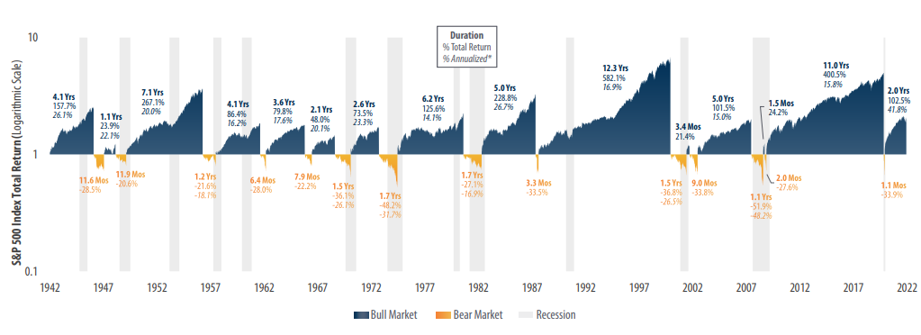
History of U.S. Bull and Bear Markets Source: First Trust. Data from 4/29/1942-3/31/2022. History of U.S. Bear & Bull Markets

While today’s challenges certainly warrant caution, they don’t have to be a reason to panic, especially when you are focused on long-term investing. Since 1942, markets have experienced numerous challenges including multiple wars, an oil embargo, asset bubbles, the Great Recession, and a global pandemic. In each of these challenges, companies and people have adapted and responded to get back on track. Investing will always be uncertain. Creating and sticking to a thoughtfully constructed investment plan is critical to avoid making short-sighted decisions. As Warren Buffet said, “the market is the most efficient mechanism anywhere in the world for transferring wealth from impatient people to patient people”.
AssetMark, Inc.
1655 Grant Street
10th Floor
Concord, CA 94520-2445
800-664-5345
IMPORTANT INFORMATION
This is for informational purposes only, is not a solicitation, and should not be considered investment, legal or tax advice. The information in this report has been drawn from sources believed to be reliable, but its accuracy is not guaranteed, and is subject to change. Investors seeking more information should contact their financial advisor. Financial advisors may seek more information by contacting AssetMark at 800-664-5345.
Investing involves risk, including the possible loss of principal. Past performance does not guarantee future results. Asset allocation cannot eliminate the risk of fluctuating prices and uncertain returns. There is no guarantee that a diversified portfolio will outperform a non-diversified portfolio. No investment strategy, such as asset allocation, can guarantee a profit or protect against loss. Actual client results will vary based on investment selection, timing, market conditions, and tax situation. It is not possible to invest directly in an index. Indexes are unmanaged, do not incur management fees, costs and expenses and cannot be invested in directly. Index performance assumes the reinvestment of dividends.
Investments in equities, bonds, options, and other securities, whether held individually or through mutual funds and exchange traded funds, can decline significantly in response to adverse market conditions, company-specific events, changes in exchange rates, and domestic, international, economic, and political developments.
Bloomberg® and the referenced Bloomberg Index are service marks of Bloomberg Finance L.P. and its affiliates, (collectively, “Bloomberg”) and are used under license. Bloomberg does not approve or endorse this material, nor guarantees the accuracy or completeness of any information herein. Bloomberg and AssetMark, Inc. are separate and unaffiliated companies.
Please read the Terms of Use posted at www.ewealthmanager.com that govern the use of these materials and also be advised:
AssetMark uses financial market information (“Information”) from third-party providers (“Providers”) in reports (“Materials”). The Information includes, but is not limited to, financial market data, quotes, news, analyst opinions and research reports. The Materials are for informational purposes only, not a solicitation or for use in the creation/management/offering/sale of any financial instrument or product based thereon and should not be considered investment, legal or tax advice. The Information has been drawn from sources believed to be reliable, but its accuracy and timeliness is not guaranteed, and is subject to change. You agree that neither AssetMark nor the Providers are liable for the use of the Information.
You agree not to redistribute the Information to recipients not authorized by AssetMark. You agree that the Providers are considered to be third-party beneficiaries of the Terms of Use.
AssetMark, Inc. is an investment adviser registered with the U.S. Securities and Exchange Commission. AssetMark and third-party service providers are separate and unaffiliated companies. Each party is responsible for their own content and services.
©2022 AssetMark, Inc. All rights reserved.
104203 | C22-18868 | 06/2022 | EXP 06/30/2024

IMPORTANT INFORMATION
This is for informational purposes only, is not a solicitation, and should not be considered investment, legal or tax advice. The information in this report has been drawn from sources believed to be reliable, but its accuracy is not guaranteed, and is subject to change. Investors seeking more information should contact their financial advisor. Financial advisors may seek more information by contacting AssetMark at 800-664-5345.
Investing involves risk, including the possible loss of principal. Past performance does not guarantee future results. Asset allocation cannot eliminate the risk of fluctuating prices and uncertain returns. There is no guarantee that a diversified portfolio will outperform a non-diversified portfolio. No investment strategy, such as asset allocation, can guarantee a profit or protect against loss. Actual client results will vary based on investment selection, timing, market conditions, and tax situation. It is not possible to invest directly in an index. Indexes are unmanaged, do not incur management fees, costs and expenses and cannot be invested in directly. Index performance assumes the reinvestment of dividends.
Investments in equities, bonds, options, and other securities, whether held individually or through mutual funds and exchange traded funds, can decline significantly in response to adverse market conditions, company-specific events, changes in exchange rates, and domestic, international, economic, and political developments.
AssetMark, Inc. is an investment adviser registered with the U.S. Securities and Exchange Commission. AssetMark and third-party service providers are separate and unaffiliated companies. Each party is responsible for their own content and services.
©2022 AssetMark, Inc. All rights reserved.
103305 | C22-18578 | 05/2022 | EXP 05/31/2024

AssetMark, Inc.
1655 Grant Street
10th Floor
Concord, CA 94520-2445
800-664-5345

https://www.ftportfolios.com/Common/ContentFileLoader.aspx?ContentGUID=4ecfa978-d0bb-4924-92c8-628ff9bfe12d

